LIBRARY MANAGEMENT SYSTEM

LAB REPORT

***Submitted by***

Shaurya Singh Srinet (RA2111032010006)

***Under the Guidance of***

Dr. Gouthaman. P

**Assistant Professor, Department of Networking and Communications**

***In partial satisfaction of the requirements for the degree of***

BACHELOR OF TECHNOLOGY

in

COMPUTER SCIENCE AND ENGINEERING

with specialization in Internet of Things



SCHOOL OF COMPUTING

COLLEGE OF ENGINEERING AND TECHNOLOGY

SRM INSTITUTE OF SCIENCE AND TECHNOLOGY KATTANKULATHUR - 603203

**MAY 2023**

|  |  |
| --- | --- |
|  | COLLEGE OF ENGINEERING & TECHNOLOGY SRM INSTITUTE OF SCIENCE & TECHNOLOGY  S.R.M. NAGAR, KATTANKULATHUE – 603 203  Chengalpattu District |

**BONAFIDE CERTIFICATE**

ii iiiiiIiI

Register No. RA2111032010006 Certified to be the

bonafide work done by Shaurya Singh Srinet of II Year/IV Sem B. Tech Degree Course in the **Practical Course – 18CSC206J - Software Engineering and Project Management** in **SRM INSTITUTE OF SCIENCE AND TECHNOLOGY,** Kattankulathur during the academic year 2022 – 2023.

|  |  |
| --- | --- |
| **SIGNATURE**  Faculty In-Charge **Dr. Gouthaman. P** Assistant Professor  Department of Networking and Communications SRM Institute of Science and Technology | **SIGNATURE**  **HEAD OF THE DEPARTMENT**  **Dr. Annapurani Panaiyappan. K**  Professor and Head,  Department of Networking and Communications SRM Institute of Science and Technology |

**ABSTRACT**

iii

The management of book libraries in large organizations and companies is a complex and challenging task that requires an efficient and secure system. The current process of managing libraries often lacks efficiency, accuracy, and security, which can lead to data inconsistency and integrity issues. Therefore, this report presents the development of a Library Management System designed to automate the processes involved in managing a library and enhance the user experience.

The proposed system provides a basic set of features that enable librarians to add/update members, add/update books, and manage check-ins. Additionally, the system maintains records of issued books, late fines for students who return books after the due date, and stock availability in the library. The development of the system includes establishing and maintaining a back-end database and front-end application development aspects that ensure strong data security and good libraries.

The system's design aims to enhance the user experience by providing a fully functional and easy-to-use application. The system allows librarians to retrieve details of books available in the library, issue books to students, and maintain their records. The proposed system provides an efficient and secure way to manage book libraries in large organizations and companies.

Overall, the development of this Library Management System provides an opportunity for organizations to streamline their library management processes, reduce the risk of data inconsistency and integrity issues, and improve the user experience. The proposed system can be further improved and customized based on the client's specific requirements and can serve as a model for future library management systems.

**TABLE OF CONTENTS**

iv

iii

|  |  |  |
| --- | --- | --- |
| **EXP**  **NO** | **TITLE** | **PAGE NO** |
|  | **ABSTRACT** | iii |
|  | **LIST OF FIGURES** | v |
|  | **LIST OF ABBREVIATIONS** | vi |
| **1** | **PROBLEM STATEMENT** | 1 |
| **2** | **STAKEHOLDERS & PROCESS MODELS** | 4 |
| **3** | **IDENTIFYING REQUIREMENTS** | 7 |
| **4** | **PROJECT PLAN & EFFORT** | 11 |
| **5** | **WORK BREAKDOWN STRUCTURE & RISK ANALYSIS** | 15 |
| **6** | **SYSTEM ARCHITECTURE, USE CASE & CLASS DIAGRAM** | 21 |
| **7** | **ENTITY RELATIONSHIP DIAGRAM** | 25 |
| **8** | **DATA FLOW DIAGRAM** | 27 |
| **9** | **SEQUENCE & COLLABORATION DIAGRAM** | 30 |
| **10** | **DEVELOPMENT OF TESTING FRAMEWORK/USER INTERFACE** | 33 |
| **11** | **TEST CASES & REPORTING** | 37 |
| **12** | **ARCHITECTURE/DESIGN/FRAMEWORK/IMPLEMENTATION** | 42 |
|  | **CONCLUSION** |  |
|  | **REFERENCES** |  |

**LIST OF FIGURES**

v

|  |  |  |
| --- | --- | --- |
| FIGURE NO | TITLE | PAGE NO |
| 5.1 | TREE STRUCTURE VIEW | 17 |
| 5.2 | GANTT CHART | 18 |
| 6.1 | SYSTEM ARCHITECTURE | 22 |
| 6.2 | USE CASE DIAGRAM | 23 |
| 6.3 | CLASS CASE DIAGRAM | 24 |
| 7.1 | ER DIAGRAM | 26 |
| 8.1 | DFD LEVEL 0 | 28 |
| 8.2 | DFD LEVEL 1 | 29 |
| 9.1 | SEQUENCE DIAGRAM | 31 |
| 9.2 | COLLABORATION DIAGRAM | 32 |
| 10.1 | UI DESIGN EXAMPLE | 36 |
| 12.1 | DASHBOARD UI | 43 |
| 12.2 | MANAGING BOOK LIST UI | 44 |
| 12.3 | ISSUE/RETURN BOOK UI | 44 |

**LIST OF ABBREVIATIONS**

vi

|  |  |  |
| --- | --- | --- |
| NO | WORD | ABBREVIATION |
| 1 | TSV | TREE STRUCTURE VIEW |
| 2 | WBS | WORK BREAKDOWN STRUCTURE |
| 3 | ER | ENTITY RELATION |
| 4 | DFD | DATA FLOW DIAGRAM |
| 5 | UI | USER INTERFACE |
| 6 | SWOT | STRENGTHS, WEAKNESSES, OPPORTUNITIES AND THREATS |
| 7 | RMMM | RISK MITIGATION, MONITORING AND MANAGEMENT |



**School of Computing**

**SRM IST, Kattankulathur – 603 203**

**Course Code: 18CSC206J**

**Course Name: Software Engineering and Project Management**

|  |  |
| --- | --- |
| **Experiment No** | 1 |
| **Title of Experiment** | To identify the Software Project, Create Business Case, Arrive at a Problem Statement |
| **Name of the candidate** | Shaurya Singh Srinet |
| **Team Members** | Shounak Chandra, Parth Galhotra |
| **Register Number** | RA2111032010006, RA2111032010026, RA2111032010029 |
| **Date of Experiment** | 20.01.23 |

**Mark Split Up**

|  |  |  |  |
| --- | --- | --- | --- |
| **S.No** | **Description** | **Maximum Mark** | **Mark Obtained** |
| 1 | Exercise | 5 |  |
| 2 | Viva | 5 |  |
| **Total** | | **10** |  |

**Staff Signature with date**

1

**Aim:**

To Frame a project team, analyze, and identify a Software project. To create a business case and Arrive at a Problem Statement for the Library Management System

**Team Members:**

|  |  |  |  |
| --- | --- | --- | --- |
| **S. No** | **Register No** | **Name** | **Role** |
| **1** | **RA2111032010006** | **Shaurya Srinet** | **Lead/Rep** |
| **2** | **RA2111032010026** | **Shounak Chandra** | **Member** |
| **3** | **RA2111032010029** | **Parth Galhotra** | **Member** |

**Project Title: Library Management System**

**Project Description:**

Usually, large companies and organizations have a vast army of human resources working under them. The Library Management System is an application for assisting a librarian in managing a book library in a university. The system would provide a basic set of features to add/update members, add/update books, and manage check in specifications for the systems based on the client’s statement of need. Its Development includes the establishment and maintenance of back-end database and front-end application development aspects. For the former require the establishment of data consistency and integrity of the strong data security and good libraries. As for the latter requires the application fully functional, easy to use and so on. This project aims to build a Library Management System which mainly focuses on basic operations in a library like adding new books, and updating new information, searching books and members, and returning books. We can enter the record of new books and retrieve the details of books available in the library. We can issue the books to the students and maintain their records and can also check how many books are issued and stock available in the library. In this project we can maintain the late fine of students who return the issued books after the due date.

**Business Case**

**The Project:**

* The Library Management System aims to streamline the administration system in a Library.
* It provides an interface which provides easy and concise access to the management of a library.
* Work can be done by a very small number of people.
* This project can free up manual labor costs which in turn can be used to implement additional value-added services.

2

**The History:**

* In managing a library and its records, excess of physical records which must be stored which takes up space and time.
* The greater amount of funds has been put to the labour in managing the library.
* False return and borrow claims are being forged in various cases.
* Automating the management can help streamline the process safely and securely.

**Limitations:**

* High end encryptions not used so it can be hacked.
* Multi-Platform usage may be limited.
* Takes time to be integrated into the workflow of the company.
* User level restrictions are very lenient.

**Approach:**

* The management system can ensure efficient access to information which is imperative for businesses.
* It can facilitate continued professional development and self-lead training.
* Very easy to learn which anyone in staff can make use of it without prior knowledge.
* Electronic information is easier to search through than physical texts.
* Ability to add on additional services if needed.

**Benefits:**

* The borrower details are stored & maintained.
* It is easy to do library audits any time as records are maintained by the highly efficient software which is easy to access.
* It is simple to maximize performance of the libraries with the dynamic reports, graphs, and charts to review or track progress for better decision-making.
* Such systems are often updated & maintained just to ensure that user databases are confidential and secure at every time.
* The automated system allows flexible information access.
* It also allows the users to access information both offline and online even on their mobile phones.

**Result:**

Thus, the project team formed, the project is described, the business case was prepared, and the problem statement was arrived.

3



**School of Computing**

**SRM IST, Kattankulathur – 603 203**

**Course Code: 18CSC206J**

**Course Name: Software Engineering and Project Management**

|  |  |
| --- | --- |
| **Experiment No** | 2 |
| **Title of Experiment** | Identification of Process Methodology and Stakeholder Description |
| **Name of the candidate** | Shaurya Singh Srinet |
| **Team Members** | Shounak Chandra, Parth Galhotra |
| **Register Number** | RA2111032010006, RA2111032010026, RA2111032010029 |
| **Date of Experiment** | 31.01.23 |

**Mark Split Up**

|  |  |  |  |
| --- | --- | --- | --- |
| **S.No** | **Description** | **Maximum Mark** | **Mark Obtained** |
| 1 | Exercise | 5 |  |
| 2 | Viva | 5 |  |
| **Total** | | **10** |  |

**Staff Signature with date**

4

**Aim:**

To identify the appropriate Process Model for the project and prepare Stakeholder and User Description.

**Team Members:**

|  |  |  |  |
| --- | --- | --- | --- |
| **Sl No** | **Register No** | **Name** | **Role** |
| **1** | **RA2111032010006** | **Shaurya Singh Srinet** | **Rep/Member** |
| **2** | **RA2111032010026** | **Shounak Chandra** | **Member** |
| **3** | **RA2111032010029** | **Parth Galhotra** | **Member** |

**Project Title: Library Management System**

**Waterfall Methodology**

**Definition of objectives:**

a) To build a system that can receive input and generate automatically output in easy way and short time.

b) To build a monitoring system that can monitor and manage all library operations efficiently.

c) Give an opportunity to librarians to reduce mistakes that always happen during manual method.

d) To store properly the library items to maintain their security.

e) To enter and preserve details of the various issues and keep a track on their returns.

**Specifications of requirements:**

In this step, there are two main operations: problem comprehension or review and definition of specifications. The goal of problem analysis is to consider the issue and its context, as well as the specifications of the new method to be created. The specifications must be defined in

the requirement specification document until the issue is evaluated and the fundamentals understood. Both technical and performance specifications must be defined in the requirements document, the formats of inputs and outputs etc.

**System selection:**

A library management system is an example of an information system. An information system, whether it is computerised or not, is a system that represents objects in a physical system, for example, information resources in a library collection.

**System implementation:**

The process starts with the entities involved in the system, with proceeding towards the ER Diagram to identify the meaningful relationship between the entities. Next is the table design which fulfils the normalization principle of relational database systems and finally the physical tables are created with the necessary and relevant data in them.

5

**System evaluation:**

* The way the management structure functions.
* Internal operations relating to information materials, such as cataloguing and classification, indexing, etc.
* Library/information services to users.
* New programmes of service delivery.

**User Stories:**

* As a librarian, I want to be able to store the data of the students who come and issue a book from the library.
* As a developer, I want to be able to find and display topic specific resources so that I can customize a topic based on the library web site.
* As a student, I want to be able to quickly browse through the website so that I can find books related to my topic with minimal time investment.
* As a student, I want to be able to find different genres of books so that l can pick books of my interest.
* As a teacher, I want to be able to find books related to my course so that l can use that as a reference and to make notes for the students.

**Information table regarding stakeholders of the project:**

|  |  |  |  |
| --- | --- | --- | --- |
| **Stakeholder Name** | **Interest** | **Influence** | **Priority (High/ Medium/ Low)** |
| Library Owner | Achieve targets, overseeing the daily operations of a library at the public or private level. | High | 1 |
| Library Manager | Responsible for the daily operations of a library at the public or private level. | High | 3 |
| Cataloguing Librarian | Provide continuous cataloging training for library staff. | High | 6 |
| Acquisition Manager | Responsible for ensuring any acquisition made by your employer is sound and reasonable. | High | 4 |
| Finance Manager | Oversee the financial health of the organization. | High | 5 |
| Library Consultant | Consult on automated services with member libraries in the System. | Low | 7 |
| Funders | Organizing fundraising events and working with volunteers. Writing funding proposals and sending these to potential sponsors. | High | 2 |
| Students | Opportunities to check on books, conduct their research work and provides feedback. | Low | 9 |
| Teachers | Conduct their research work, teaching materials and provide feedback. | Low | 8 |

**Result:**

Thus, the Project Methodology was identified, and the stakeholders were described.

6



**School of Computing**

**SRM IST, Kattankulathur – 603 203**

**Course Code: 18CSC206J**

**Course Name: Software Engineering and Project Management**

|  |  |
| --- | --- |
| **Experiment No** | 3 |
| **Title of Experiment** | System, Functional and Non-Functional Requirements of the Project |
| **Name of the candidate** | Shaurya Singh Srinet |
| **Team Members** | Shounak Chandra, Parth Galhotra |
| **Register Number** | RA2111032010006, RA2111032010026, RA2111032010029 |
| **Date of Experiment** | 7.2.23 |

**Mark Split Up**

|  |  |  |  |
| --- | --- | --- | --- |
| **S. No** | **Description** | **Maximum Mark** | **Mark Obtained** |
| 1 | Exercise | 5 |  |
| 2 | Viva | 5 |  |
| **Total** | | **10** |  |

**Staff Signature with date**

7

**Aim**

To identify the system, functional and non-functional requirements for the project.

**Team Members:**

|  |  |  |  |
| --- | --- | --- | --- |
| **S No** | **Register No** | **Name** | **Role** |
| **1** | **RA2111032010006** | **Shaurya Singh Srinet** | **Rep/Member** |
| **2** | **RA2111032010026** | **Shounak Chandra** | **Member** |
| **3** | **RA2111032010029** | **Parth Galhotra** | **Member** |

**Project Title:** Library Management System

**System Requirements:**

|  |  |  |  |  |
| --- | --- | --- | --- | --- |
| **Requirement (#)** | **Requirement Specification** | **Department** | **Name of Business**  **User / Project**  **Team Member** | **Status** |
| IR1 | Development Machine with 6 GB Ram and 4 Cores | Technical Team | Shaurya Singh Srinet | Team Lead |
| IR2 | Code Repository | Technical Team | Parth Galhotra | Team Member,  Cross Platform |
| IR3 | AWS S3 Bucket | Technical Team | Shounak Chandra | Team Member,  Data Analytics |
| IR4 | IDE – Visual Studio  Code | Technical Team | All Members | Technical Team  Members |

8

**Non-Functional Requirements:**

|  |  |  |  |  |  |
| --- | --- | --- | --- | --- | --- |
| **Requirement (#)** | **Category of NFR** | **Requirement Specification** | **Department** | **Name of Business**  **User** | **Status** |
| NFR1 | Performance | All pages should load within 3 seconds. | Department of Media | Mr. Alok Sharma | Editor in Chief |
| NFR2 | Performance | Search should bring the results less than 7 seconds. | Business  Development | Dr. Vivek Bindra | Business Coach |
| NFR3 | Availability | Application should be available for 24x7. | Medical  Consultancy | G.N.S Krishna Murthi | Medical  Representative |
| NFR4 | Accessibility | Should be easy to use for a 3rd party. | Management | Jivan Anand | Restaurant  Owner |
| NFR5 | Scalability | Database should be large enough  to support many books. | Tourist | Paul Johnson | Traveller and  Photographer |
| E1NFR1 | Security | Should have security to ensure privacy of data. | N/A | Mrs. Das | Housewife |

9

**Functional Requirements:**

|  |  |  |  |  |
| --- | --- | --- | --- | --- |
| **Requirement (#)** | **Requirement Specification** | **Department** | **Name of Business**  **User** | **Status** |
| E1FR1 | The system must be able to add delete and view books we should be able to search book based on book name. | Department of Media | Ms. Ankita Singh | Journalism |
| E1FR2 | System must be able to enter issue information in the database. -System must be able to update number of books. | Resort Management | Mr. Anil Verma | Resort Manager |
| E1FR3 | System should be able to recommend popular books available for purchase | Technical Team, XYZ | XYZ Software Solutions and  Consultancy. | SDE 1 |

**Result:**

Thus, the requirements were identified and accordingly described.

10



**School of Computing**

**SRM IST, Kattankulathur – 603 203**

**Course Code: 18CSC206J**

**Course Name: Software Engineering and Project Management**

|  |  |
| --- | --- |
| **Experiment No** | 4 |
| **Title of Experiment** | Prepare Project Plan based on scope, Calculate Project effort based on resources and Job roles and responsibilities |
| **Name of the candidate** | Shaurya Singh Srinet |
| **Team Members** | Shounak Chandra, Parth Galhotra |
| **Register Number** | RA2111032010006, RA2111032010026, RA2111032010029 |
| **Date of Experiment** | 09.02.23 |

**Mark Split Up**

|  |  |  |  |
| --- | --- | --- | --- |
| **S. No** | **Description** | **Maximum Mark** | **Mark Obtained** |
| 1 | Exercise | 5 |  |
| 2 | Viva | 5 |  |
| **Total** | | **10** |  |

**Staff Signature with date**

11

**Aim:**

To Prepare Project Plan based on scope, Calculate Project effort based on resources, Find Job roles and responsibilities

**Team Members:**

|  |  |  |  |
| --- | --- | --- | --- |
| **S No** | **Register No** | **Name** | **Role** |
| **1** | **RA2111032010006** | **Shaurya Singh Srinet** | **Rep/Member** |
| **2** | **RA2111032010026** | **Shounak Chandra** | **Member** |
| **3** | **RA2111032010029** | **Parth Galhotra** | **Member** |

**Requirements:**

1. **Project Management Plan:**

|  |  |
| --- | --- |
| **Focus Area** | **Details** |
| Integration Management | Governance Framework, Project Team Structure, Roles &amp; Responsibilities of Team, Change Management, (Change Control, Issue Management), Project Closure |
| Scope Management | Scope Statement, Requirement Management (Gathering, Control, Assumption, Constraint Stakeholder), Define Deliverables, Requirement Change Control, Activities and Sub-Tasks |
| Cost Management | Estimate Effort, Assign Team, Budget Control |
| Quality Management | Quality Assurance: Quality assurance will be managed including governance, roles and responsibilities, tools and techniques and reporting  Quality Control: Specify the mechanisms to be used to measure and control the quality of the work products |
| Resource Management | Estimate and manage the need  People: People & Skills Required  Finance: Budget Required  Physical: Facilities, IT Infrastructure |
| Stakeholder | Identifying, Analyzing, Engaging Stakeholders |
| Risk Management | Identifying, analyzing, and prioritizing project risks |

12

1. **Estimation:**
   1. **Effort and Cost Estimation:**

|  |  |  |  |  |
| --- | --- | --- | --- | --- |
| **Activity Description** | **Sub-Task** | **Sub-Task Description** | **Effort (in hrs)** | **Cost in INR** |
| Web Application  Development | E1R1A1T1 | To create desktop level  Web Application using Python, Flask and SQL | 6-8 | SQL dev-100K Frontend-43K  Backend-100K |
| Research and  Development | E2R2A2T2 | Evaluation of software  technology trends and  incorporating them with updates and patches | 4 | For Research - 20K  For rolling out patches/updates – 50K |
| Data Analytics | E3R3A3T3 | Administrator of Data, Database Management, Evaluating trends in data | 10 with shifts | Data Analyst-100K  Data Scientist-90K  Database Manager 56K |
| Help & Support | E4R4A4T4 | Customer care | 24 with shifts | Customer  Care-70K to 80K |
| Licensing/  Trademarks/  Copyrighting | E5R5A5T5 | Database, IDE, Server,  Terms, Trademarking,  Copyrighting | All time | 25K (one time) |
| Marketing | E6R6A6T6 | Advertisements, Public Relations | 8-10  On requirement | Manager– 68K  Coordinator–50K  Assistant–25K |
| Testers | E7R7A7T7 | To test the functionality of the software in expected and unexpected conditions | 4 | 240K (one time) |

* 1. **Infrastructure/Resource Cost [CapEx]:**

|  |  |  |  |
| --- | --- | --- | --- |
| **Infrastructure Requirement** | **Qty** | **Cost per qty** | **Cost per item** |
| Laptops | 3 | 60,000 | 1,80,000 |
| Telephones | 15 | 1,500 | 22,500 |
| PCs | 15 | 80,000 | 12,00,000 |
| Printers | 2 | 5,000 | 10,000 |
| Office Rooms (Rent) | 5 | 25,000 per month | 1,25,000 |

**2.3. Maintenance and Support Cost [OpEx]:**

|  |  |  |  |  |
| --- | --- | --- | --- | --- |
| **Category** | **Details** | **Qty** | **Cost per qty per annum** | **Cost per item** |
| People | Network, DB  Admin, Customer support,  Developers | 4 | 10,00,000 | 40,00,000 |
| License | Database, server, Middleware, Government License | 3 | 10,000 | 30,000 |
| Infrastructures | Server Storage and Network | 1 | 10,000 | 20,000 |

13

1. **Project Team Formation:**
   1. **Identification Team Members:**

|  |  |  |
| --- | --- | --- |
| **Name** | **Role** | **Responsibilities** |
| Shaurya Srinet | Project Lead | Design end-to-end architecture, provide training and support, team management, monitoring and  controlling |
| Parth Galhotra | UX Designer | Design overall visual user experience |
| Parth Galhotra | Frontend Developer | Develop user interface |
| Shounak Chandra | Backend Developer | Coding and Debugging, UI testing to optimize  performance, maintaining database |
| Shaurya Srinet | Quality Assurance Lead | Come up with questionnaires and surveys, random quality checks |
| Shounak Chandra | Tester | Perform testing for various test cases, identifying flaws |

* 1. **Responsibility Assignment Matrix:**

|  |  |  |  |  |
| --- | --- | --- | --- | --- |
| **RACI Matrix** | **Team Members** | | | |
| **Activity** | **Name (BA)** | **Name (Developer)** | **Name (Project Manager)** | **Key Business User** |
| User Requirement Documentation | A | C | I | R |
| Web Application Development | I | R | A | C |
| Data Analytics | C | R | A | I |
| Research and Development | I | R | A | C |
| Testing | I | R | A | C |
| Marketing | C | I | A | R |

|  |  |
| --- | --- |
| A | Accountable |
| R | Responsible |
| C | Consult |
| I | Inform |

**Result:**

Thus, the Project Plan was documented successfully.

14



**School of Computing**

**SRM IST, Kattankulathur – 603 203**

**Course Code: 18CSC206J**

**Course Name: Software Engineering and Project Management**

|  |  |
| --- | --- |
| **Experiment No** | 5 |
| **Title of Experiment** | Prepare Work breakdown structure, Timeline chart, Risk identification table |
| **Name of the candidate** | Shaurya Singh Srinet |
| **Team Members** | Shounak Chandra, Parth Galhotra |
| **Register Number** | RA2111032010006, RA2111032010026, RA2111032010029 |
| **Date of Experiment** | 21.02.2023 |

**Mark Split Up**

|  |  |  |  |
| --- | --- | --- | --- |
| **S. No** | **Description** | **Maximum Mark** | **Mark Obtained** |
| 1 | Exercise | 5 |  |
| 2 | Viva | 5 |  |
| **Total** | | **10** |  |

**Staff Signature with date**

15

**Aim:**

To Prepare Work breakdown structure, Timeline chart and Risk identification table

**Team Members:**

|  |  |  |  |
| --- | --- | --- | --- |
| **Sl No** | **Register No** | **Name** | **Role** |
| **1** | **RA2111032010006** | **Shaurya Singh Srinet** | **Rep/Member** |
| **2** | **RA2111032010026** | **Shounak Chandra** | **Member** |
| **3** | **RA2111032010029** | **Parth Galhotra** | **Member** |

**WORK BREAKDOWN STRUCTURE:**

The WBS is a view into the project that illustrates the work the project encompasses. The Project Manager and project team use the WBS to develop the project schedule, resource requirements, and costs.

1. Library Management System (Deliverable) scope
   1. Basic Desktop level Application Frame
      1. Entry Page
         1. Login Tab
         2. Signup Tab
         3. Terms and Conditions Hyperlink
         4. Basic Entry Level Support Hyperlink
      2. Home page
         1. Dashboard tab
         2. Help and Support tab
         3. Logout button
         4. Credentials tab
         5. About Us tab
   2. Supporting Project scope
      1. Project Management
      2. Security
      3. Software testing
      4. Documentation

16

**TREE STRUCTURE VIEW**

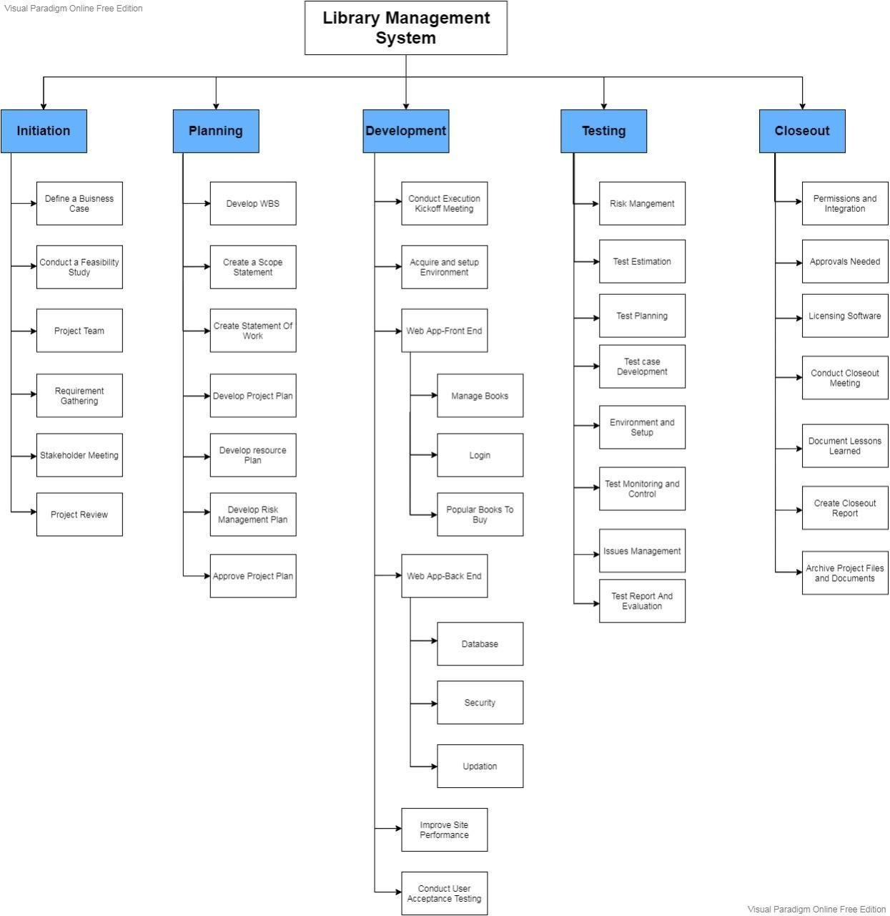

The Tree Structure View is the most popular format for the WBS. It presents an easy-to- understand view into the WBS; however, it is also tricky to create without an application specifically designed for creating this organizational chart structure. The Tree Structure below was created using only Microsoft Word and the SmartArt graphics option under the insert menu.

17

**TIMELINE – GANTT CHART**

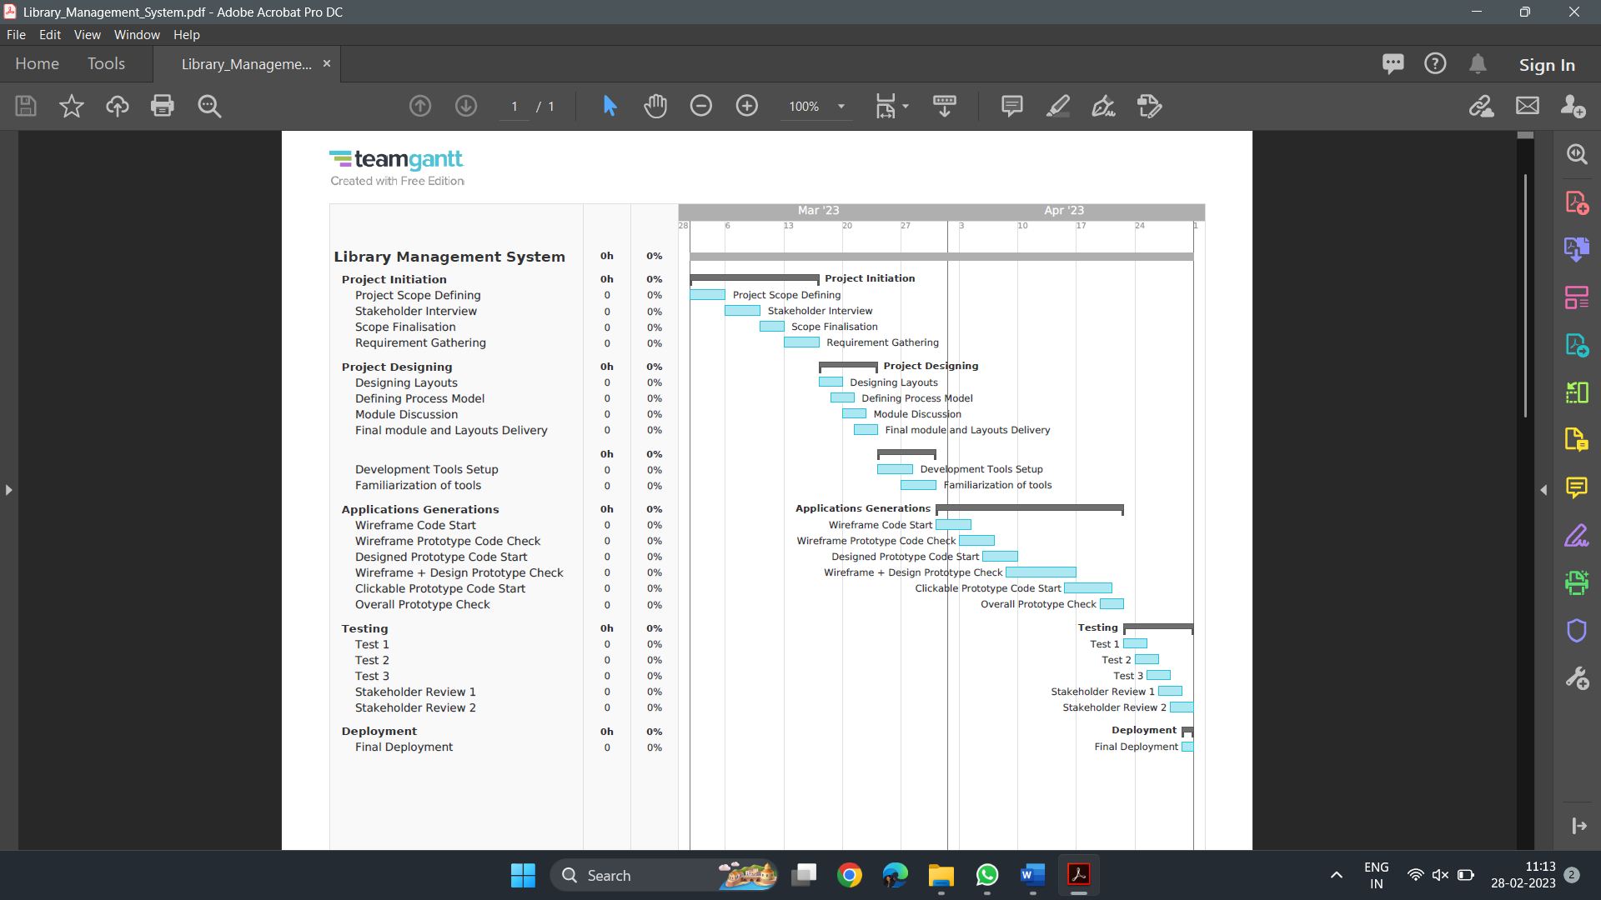

18

**RISK ANALYSIS – SWOT & RMMM**

**SWOT Analysis:**

19

|  |  |
| --- | --- |
| **Strengths**   * Efficient management of library resources * Improved user experience * Automation of library tasks * Accurate reporting | **Weaknesses**   * Initial implementation costs * Technical issues * Dependence on technology * Limited flexibility |
| **Opportunities**   * Integration with other systems * Cloud-based systems * Mobile accessibility * E-books and digital media | **Threats**   * Budget constraints * Competition from other libraries * Security threats * Resistance to change |

**RMMM Risk Table:**

The risks are categorized based on their likelihood and potential impact, with high-risk events requiring more attention and mitigation strategies. Mitigation strategies may include regular maintenance and equipment replacement planning, security audits and updates, backup systems in place, staff training on data protection, and contingency plans.

|  |  |  |  |  |
| --- | --- | --- | --- | --- |
| **Level of Risk** | **Description** | **Likelihood** | **Impact** | **RMMM Plan** |
| High | Major security breach | High | High | Regular security audits and updates, encryption of sensitive data, staff training on data protection |
| Medium | Major equipment Failure | Medium | High | Regular maintenance and equipment replacement planning, backup systems in place, contingency plans |
| Medium | Loss of library materials | Medium | Medium | Regular inventory checks, security measures to prevent theft, backup copies or digitization of important materials |
| Low | Staff Shortage | Low | Low | Cross-training of staff, flexible scheduling, recruitment, and retention strategies |
| Low | Minor equipment failure | Low | Low | Regular maintenance and repair, backup systems in place |
| Low | Minor security breach | Low | Low | Regular security audits and updates, staff training on data protection |

**Result:**

Thus, the work breakdown structure with timeline chart and risk table were formulated successfully

20



**School of Computing**

**SRM IST, Kattankulathur – 603 203**

**Course Code: 18CSC206J**

**Course Name: Software Engineering and Project Management**

|  |  |
| --- | --- |
| **Experiment No** | 6 |
| **Title of Experiment** | Design a System Architecture, Use Case and Class Diagram |
| **Name of the candidate** | Shaurya Singh Srinet |
| **Team Members** | Shounak Chandra, Parth Galhotra |
| **Register Number** | RA2111032010006, RA2111032010026, RA2111032010029 |
| **Date of Experiment** | 28.2.23 |

**Mark Split Up**

|  |  |  |  |
| --- | --- | --- | --- |
| **S. No** | **Description** | **Maximum Mark** | **Mark Obtained** |
| 1 | Exercise | 5 |  |
| 2 | Viva | 5 |  |
| **Total** | | **10** |  |

**Staff Signature with date**

21

**Aim:**

To Design a System Architecture, Use case and Class Diagram

**Team Members:**

|  |  |  |  |
| --- | --- | --- | --- |
| **S. No** | **Register No** | **Name** | **Role** |
| **1** | **RA2111032010006** | **Shaurya Singh Srinet** | **Representative** |
| **2** | **RA2111032010026** | **Shounak Chandra** | **Member** |
| **3** | **RA2111032010029** | **Parth Galhotra** | **Member** |

**SYSTEM ARCHITECTURE**

**Architecture of library management system:**

Library management system has 4 architectures.

1. Add or create user and book.

2. Delete user or book

3. Update information

4. Search book or user

Basic architecture of a library management system is given below:

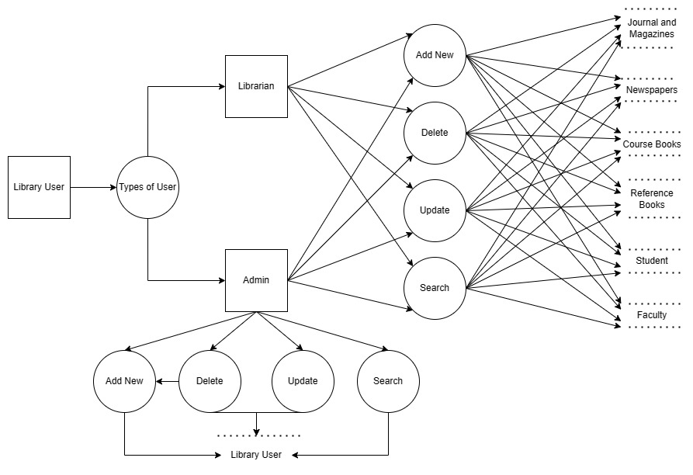

22

**USE CASE DIAGRAM**

A use case diagram is a graphical depiction of a user's possible interactions with a system. A use case diagram shows various use cases and different types of users the system has and will often be accompanied by other types of diagrams as well. The use cases are represented by either circles or ellipses. The actors are often shown as stick figures.

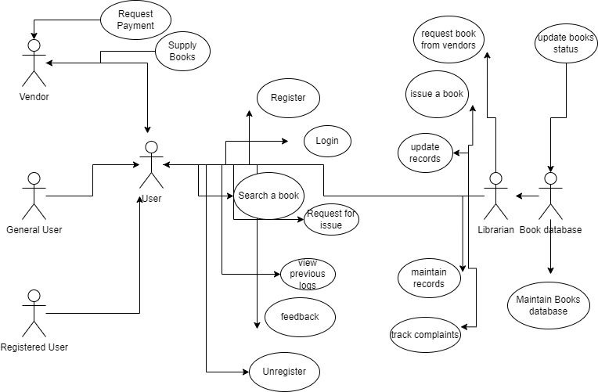

23

**CLASS DIAGRAM**

Class diagram is a static diagram. It represents the static view of an application. Class diagram is not only used for visualizing, describing, and documenting different aspects of a system but also for constructing executable code of the software application.

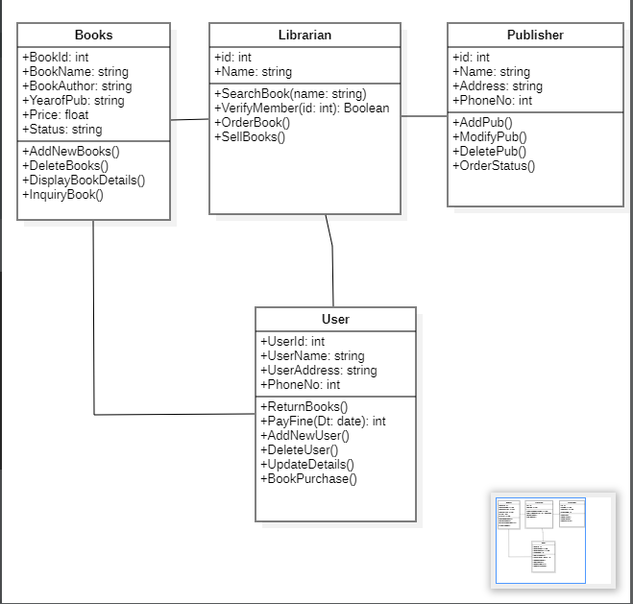

**Result:**

Thus, the system architecture, use case and class diagram created successfully.

24



**School of Computing**

**SRM IST, Kattankulathur – 603 203**

**Course Code: 18CSC206J**

**Course Name: Software Engineering and Project Management**

|  |  |
| --- | --- |
| **Experiment No** | 7 |
| **Title of Experiment** | Design an Entity relationship diagram |
| **Name of the candidate** | Shaurya Singh Srinet |
| **Team Members** | Shounak Chandra, Parth Galhotra |
| **Register Number** | RA2111032010006, RA2111032010026, RA2111032010029 |
| **Date of Experiment** | 7.3.23 |

**Mark Split Up**

|  |  |  |  |
| --- | --- | --- | --- |
| **S. No** | **Description** | **Maximum Mark** | **Mark Obtained** |
| 1 | Exercise | 5 |  |
| 2 | Viva | 5 |  |
| **Total** | | **10** |  |

**Staff Signature with date**

25

**Aim:**

To create the Entity Relationship Diagram

**Team Members:**

|  |  |  |  |
| --- | --- | --- | --- |
| **S No** | **Register No** | **Name** | **Role** |
| **1** | **RA2111032010006** | **Shaurya Singh Srinet** | **Representative** |
| **2** | **RA2111032010026** | **Shounak Chandra** | **Member** |
| **3** | **RA2111032010029** | **Parth Galhotra** | **Member** |

**ER Diagram:**

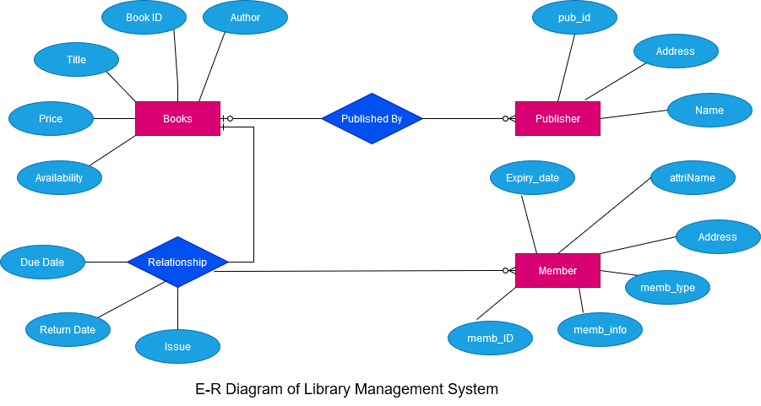

**Result:**

Thus, the entity relationship diagram was created successfully.

26



**School of Computing**

**SRM IST, Kattankulathur – 603 203**

**Course Code: 18CSC206J**

**Course Name: Software Engineering and Project Management**

|  |  |
| --- | --- |
| **Experiment No** | 8 |
| **Title of Experiment** | Develop a Data Flow Diagram (Process-Up to Level 1) |
| **Name of the candidate** | Shaurya Singh Srinet |
| **Team Members** | Shounak Chandra, Parth Galhotra |
| **Register Number** | RA2111032010006, RA2111032010026, RA2111032010029 |
| **Date of Experiment** | 15.3.23 |

**Mark Split Up**

|  |  |  |  |
| --- | --- | --- | --- |
| **S. No** | **Description** | **Maximum Mark** | **Mark Obtained** |
| 1 | Exercise | 5 |  |
| 2 | Viva | 5 |  |
| **Total** | | **10** |  |

**Staff Signature with date**

27

**Aim:**

To develop the data flow diagram up to level 1 for the Library Management System.

**Team Members:**

|  |  |  |  |
| --- | --- | --- | --- |
| **S No** | **Register No** | **Name** | **Role** |
| **1** | **RA2111032010006** | **Shaurya Singh Srinet** | **Representative** |
| **2** | **RA2111032010026** | **Shounak Chandra** | **Member** |
| **3** | **RA2111032010029** | **Parth Galhotra** | **Member** |

**Data Flow Diagram (Level 0) of Library Management System**

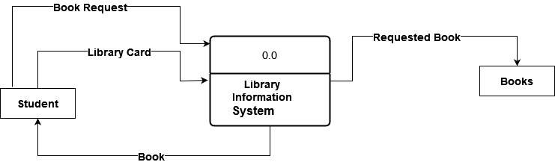

28

**Data Flow Diagram (Level 1) of Library Management System**

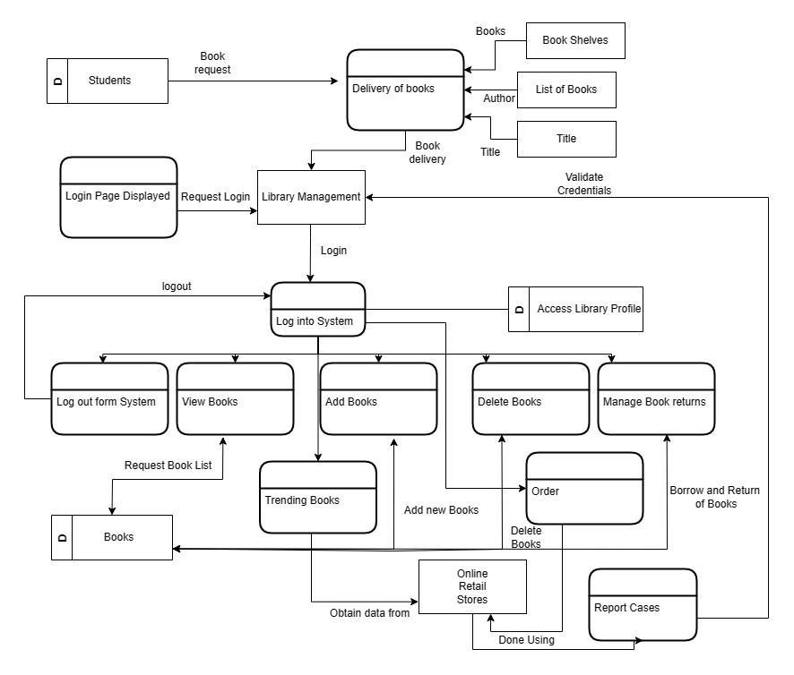

**Result:**

Thus, the data flow diagrams have been created for the Library Management System.

29



**School of Computing**

**SRM IST, Kattankulathur – 603 203**

**Course Code: 18CSC206J**

**Course Name: Software Engineering and Project Management**

|  |  |
| --- | --- |
| **Experiment No** | 9 |
| **Title of Experiment** | Design a Sequence and Collaboration Diagram. |
| **Name of the candidate** | Shaurya Singh Srinet |
| **Team Members** | Shounak Chandra, Parth Galhotra |
| **Register Number** | RA2111032010006, RA2111032010026, RA2111032010029 |
| **Date of Experiment** | 15.3.23 |

**Mark Split Up**

|  |  |  |  |
| --- | --- | --- | --- |
| **S. No** | **Description** | **Maximum Mark** | **Mark Obtained** |
| 1 | Exercise | 5 |  |
| 2 | Viva | 5 |  |
| **Total** | | **10** |  |

**Staff Signature with date**

30

**Aim:**

To create the sequence and collaboration diagram for the Library Management System.

**Team Members:**

|  |  |  |  |
| --- | --- | --- | --- |
| **S No** | **Register No** | **Name** | **Role** |
| **1** | **RA2111032010006** | **Shaurya Singh Srinet** | **Representative** |
| **2** | **RA2111032010026** | **Shounak Chandra** | **Member** |
| **3** | **RA2111032010029** | **Parth Galhotra** | **Member** |

**Sequence Diagram:**

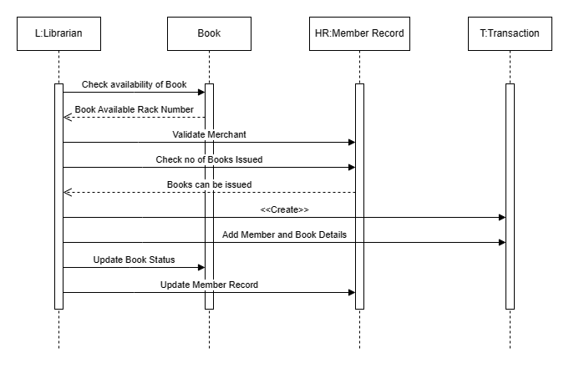

31

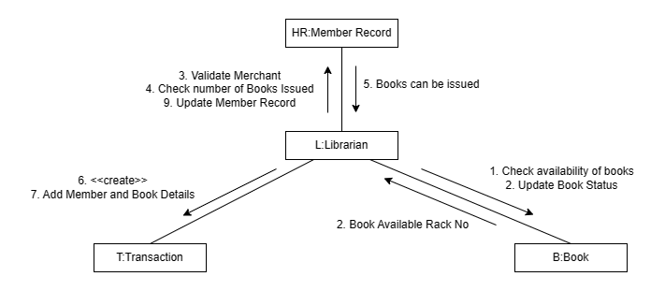**Collaboration Diagram:**

**Result:**

Thus, the sequence and collaboration diagrams were created for the Library Management System.

32



**School of Computing**

**SRM IST, Kattankulathur – 603 203**

**Course Code: 18CSC206J**

**Course Name: Software Engineering and Project Management**

|  |  |
| --- | --- |
| **Experiment No** | 10 |
| **Title of Experiment** | Developing a Testing Framework/User Interface |
| **Name of the candidate** | Shaurya Singh Srinet |
| **Team Members** | Shounak Chandra, Parth Galhotra |
| **Register Number** | RA2111032010006, RA2111032010026, RA2111032010029 |
| **Date of Experiment** | 30.3.23 |

**Mark Split Up**

|  |  |  |  |
| --- | --- | --- | --- |
| **S. No** | **Description** | **Maximum Mark** | **Mark Obtained** |
| 1 | Exercise | 5 |  |
| 2 | Viva | 5 |  |
| **Total** | | **10** |  |

**Staff Signature with date**

33

**Aim:**

To develop the testing framework and/or user interface framework for the Library Management System.

**Team Members:**

|  |  |  |  |
| --- | --- | --- | --- |
| **S No** | **Register No** | **Name** | **Role** |
| **1** | **RA2111032010006** | **Shaurya Singh Srinet** | **Rep/Member** |
| **2** | **RA2111032010026** | **Shounak Chandra** | **Member** |
| **3** | **RA2111032010029** | **Parth Galhotra** | **Member** |

**Executive Summary:**

This Module is used to manage the list of books that have been stored in database. It displays a tabular view of all the books owned by the library i.e the User. It also Gives the option to Delete A certain book from the database. A search bar may be added for additional user convenience in the same page. The module to Issue and return books has also been integrated with the current one which allows the user to issue and return books. It also tells us about the availability of the books in their current status and enables us to distinguish between them. The functionality to add books is better left as another module due to its dependencies and requirements. Further background design and QOL features may also be added to stylize the page if time permits.

**Test Plan**

**Scope of Testing**

The scope of testing for an online library management system project includes creating distinct product users based on their roles and permissions, authenticating users at their login, providing a list of books that users can borrow, and providing facilities to reserve books that are available. The system should also provide a status page for all users to view books reserved by them and allow them to cancel reservations made earlier. Additionally, it should provide a status page for all users to view books borrowed by them, their individual due dates, and their individual penalties if any. The system should also provide an interface for users to view and edit their own profile, adjust account settings such as passwords, and reset their password in case they forget it. [Staff should be provided with an interface to add or delete books](https://www.ukessays.com/essays/information-technology/the-scope-of-online-library-management-information-technology-essay.php).

34

**Types of Testing, Methodology, Tools**

|  |  |  |
| --- | --- | --- |
| Category | Methodology | Tools Required |
| Functional Requirements | Use case testing to ensure all required functionality is working. | Test management tools (e.g. TestRail), Test automation tools (e.g. Selenium), Debugging tools (e.g. Visual Studio Debugger) |
| Non-functional Requirements | Performance testing to ensure the system can handle expected loads. | Load testing tools (e.g. Apache JMeter), Security testing tools (e.g. OWASP ZAP), Usability testing tools (e.g. UserTesting.com) |
| User Interface Testing | Manual testing to ensure the user interface is intuitive and easy to use. | Documentation tools (e.g. Confluence), Screen capture tools (e.g. Snagit), Word templates for test case documentation. |
| Integration Testing | API testing to ensure that API calls to external systems work correctly. | Programming languages (e.g. Java), Frameworks (e.g. Spring), Libraries (e.g. Apache HttpClient), Databases (e.g. MySQL), Tools (e.g. Postman) |
| Category | Methodology | Tools Required |
| Acceptance Testing | User acceptance testing to ensure that the system meets user requirements. | Collaboration tools (e.g. Microsoft Teams), Test management tools (e.g. Zephyr), Test automation tools (e.g. Selenium WebDriver) |
| Book Listing and Availability | Automated testing to ensure that the book listing and availability are accurate and up-to-date. | Test automation tools (e.g. Selenium WebDriver), Programming languages (e.g. Python), Libraries (e.g. BeautifulSoup) |
| Issue and Return of Books | End-to-end testing to ensure that the system can properly issue and return books. | Test management tools (e.g. TestRail), Test automation tools (e.g. Selenium), Debugging tools (e.g. Visual Studio Debugger) |

35

**UI Design Example**

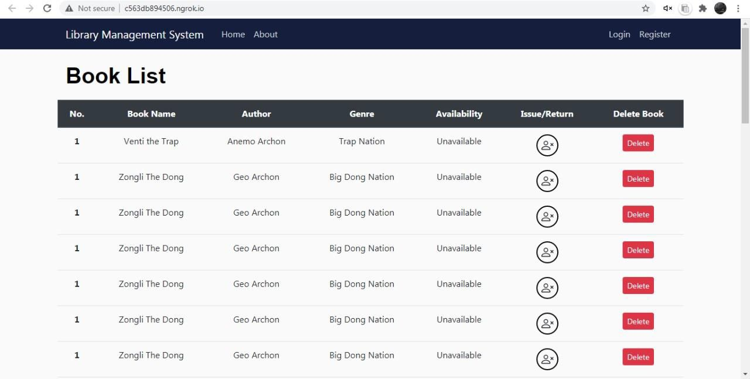

**Result**

Thus, the testing framework/user interface framework has been created for the Library Management System.

36



**School of Computing**

**SRM IST, Kattankulathur – 603 203**

**Course Code: 18CSC206J**

**Course Name: Software Engineering and Project Management**

|  |  |
| --- | --- |
| **Experiment No** | 11 |
| **Title of Experiment** | Test Case and Reporting |
| **Name of the candidate** | Shaurya Singh Srinet |
| **Team Members** | Shounak Chandra, Parth Galhotra |
| **Register Number** | RA2111032010006, RA2111032010026, RA2111032010029 |
| **Date of Experiment** | 6.4.23 |

**Mark Split Up**

|  |  |  |  |
| --- | --- | --- | --- |
| **S. No** | **Description** | **Maximum Mark** | **Mark Obtained** |
| 1 | Exercise | 5 |  |
| 2 | Viva | 5 |  |
| **Total** | | **10** |  |

**Staff Signature with date**

37

**Aim:**

To develop the test cases manual with manual test case report for the Library Management System.

**Team Members:**

|  |  |  |  |
| --- | --- | --- | --- |
| **S No** | **Register No** | **Name** | **Role** |
| **1** | **RA2111032010006** | **Shaurya Singh Srinet** | **Representative** |
| **2** | **RA2111032010026** | **Shounak Chandra** | **Member** |
| **3** | **RA2111032010029** | **Parth Galhotra** | **Member** |

**Manual Test Cases:**

1. **Register:**

|  |  |  |  |  |  |  |  |  |
| --- | --- | --- | --- | --- | --- | --- | --- | --- |
| **S. No** | **Test Case ID** | **Test**  **Objective** | **Test**  **Condition** | **Steps** | **Sample Input** | **Expected Output** | **Actual Output** | **Test**  **Status** |
| 1 | LS001 | Email without @ (invalid email) | To check  Email id | 1.Enter valid  Email id | sn0273srmist.edu.in | error | error | reject |
| 2 | LS002 | invalid password (with space) | To check  password | 1. Enter valid  password | 9515162 115 | error | error | reject |
| 3 | LS003 | Proper Email id and  password | To check  Email id and  password | 1.Enter valid  Email id  2. Enter valid  password | sn0273@srmist.edu.in  9515162115 | Successful | Successful | accept |
| 4 | LS004 | Already registered user name | To check  User name is registered before or not | 1.Enter valid  User name | Shaurya Srinet | error | error | reject |
| 5 | LS005 | Different  passwords | To check  Password | 1. Enter valid  password | 9515162115 | error | error | reject |
| 6 | LS006 | Same  passwords | To check  Password | 1. Enter valid  password | 9515162115 | Successful | Successful | accept |

38

1. **Login:**

|  |  |  |  |  |  |  |  |  |
| --- | --- | --- | --- | --- | --- | --- | --- | --- |
| **S. No** | **Test Case ID** | **Test**  **Objective** | **Test**  **Condition** | **Steps** | **Sample Input** | **Expected Output** | **Actual Output** | **Test**  **Status** |
| 1 | HM001 | Non  Registered  Email | To check  Email id | 1.Enter valid  Email id | sn0273@srmist.edu.in | error | error | reject |
| 2 | HM002 | Wrong password | To check  password | 1. Enter valid  password | 9515162 115 | error | error | reject |
| 3 | HM003 | Proper Email id and  password | To check  Email id and  password | 1.Enter valid  Email id  2. Enter valid  password | sn0273@srmist.edu.in  9515162115 | Successful | Successful | accept |

1. **Forgot Password:**

|  |  |  |  |  |  |  |  |  |
| --- | --- | --- | --- | --- | --- | --- | --- | --- |
| **S. No** | **Test Case ID** | **Test**  **Objective** | **Test**  **Condition** | **Steps** | **Sample Input** | **Expected Output** | **Actual Output** | **Test**  **Status** |
| 1 | HM004 | Non  Registered  Email | To check  Email id | 1.Enter valid  Email id | sn0273@srmist.edu.in | error | error | reject |
| 2 | HM005 | valid Email id | To check  Email id | 1.Enter valid  Email id | sn0273@srmist.edu.in | Successful | Successful | accept |

1. **Reset Password:**

|  |  |  |  |  |  |  |  |
| --- | --- | --- | --- | --- | --- | --- | --- |
| **S. No** | **Test Case ID** | **Test**  **Objective** | **Test**  **Condition** | **Steps** | **Expected Output** | **Actual Output** | **Test**  **Status** |
| 1 | HM006 | Use link sent to  Email after 30 mins | Link is working within 30 min of generation | Click the link sent to email  After 30 mins | error | error | reject |
| 2 | HM007 | Use link sent to  Email within 30 mins | Link is working within 30 min of generation | Click the link sent to email id within 30 mins | Successful | Successful | accept |

39

1. **Add/Delete Book:**

|  |  |  |  |  |  |  |  |  |
| --- | --- | --- | --- | --- | --- | --- | --- | --- |
| **S. No** | **Test Case ID** | **Test**  **Objective** | **Test**  **Condition** | **Steps** | **Sample Input** | **Expected Output** | **Actual Output** | **Test**  **Status** |
| 1 | DSB001 | Use the name of the magazine | To check  Name of the magazine | 1.Enter valid  Name of magazine | Bone | Successful | Successful | accept |
| 2 | DSB002 | Access book without logging in | To access book without logging in | 1. access book without logging in | Bone | Successful | Successful | accept |
| 3 | DSB003 | delete book without logging in | To delete book without logging in | 1. delete book without logging in | Bone | error | error | reject |

1. **Account:**

|  |  |  |  |  |  |  |  |
| --- | --- | --- | --- | --- | --- | --- | --- |
| **S. No** | **Test Case ID** | **Test**  **Objective** | **Test**  **Condition** | **Steps** | **Expected Output** | **Actual Output** | **Test**  **Status** |
| 1 | DSB007 | Update to already registered user name | TO Update already registered user name | 1. Update already registered user name | error | error | reject |
| 2 | DSB008 | Change profile pic from local files in comp | TO Change profile pic from local files in comp | 1. Change profile pic from local files in comp | Successful | Successful | accept |
| 2 | DSB009 | Use someone else profile pic | To Use someone else profile pic | 1. Use someone else profile pic | Successful | Successful | accept |

**Current status of Testing:**

The testing process has been executed and the above test cases have been passed successfully. The Library Management System seems to be working fine without any major issues.

**Obstacles to proceed further:**

There are no major obstacles that are hindering the testing process. However, there might be some minor issues that could be resolved with additional testing.

40

**Seek help from stakeholders:**

If any issues arise during the testing process, the development team can be contacted for assistance. Additionally, stakeholders can be informed about any unexpected behaviour or issues found during testing, which can help to improve the overall quality of the Library Management System.

**Result:**

Thus, the test case manual and report has been created for the Library Management System.

41



**School of Computing**

**SRM IST, Kattankulathur – 603 203**

**Course Code: 18CSC206J**

**Course Name: Software Engineering and Project Management**

|  |  |
| --- | --- |
| **Experiment No** | 12 |
| **Title of Experiment** | Provide the details of Architecture Design/Framework/ Implementation |
| **Name of the candidate** | Shaurya Singh Srinet |
| **Team Members** | Shounak Chandra, Parth Galhotra |
| **Register Number** | RA2111032010006, RA2111032010026, RA2111032010029 |
| **Date of Experiment** | 13.4.23 |

**Mark Split Up**

|  |  |  |  |
| --- | --- | --- | --- |
| **S. No** | **Description** | **Maximum Mark** | **Mark Obtained** |
| 1 | Exercise | 5 |  |
| 2 | Viva | 5 |  |
| **Total** | | **10** |  |

**Staff Signature with date**

42

**Aim:**

To provide the details of architectural design/framework/implementation

**Team Members:**

|  |  |  |  |
| --- | --- | --- | --- |
| **S No** | **Register No** | **Name** | **Role** |
| **1** | **RA2111032010006** | **Shaurya Singh Srinet** | **Representative** |
| **2** | **RA2111032010026** | **Shounak Chandra** | **Member** |
| **3** | **RA2111032010029** | **Parth Galhotra** | **Member** |

**Architectural Design:**

1. Dashboard(Home) Design

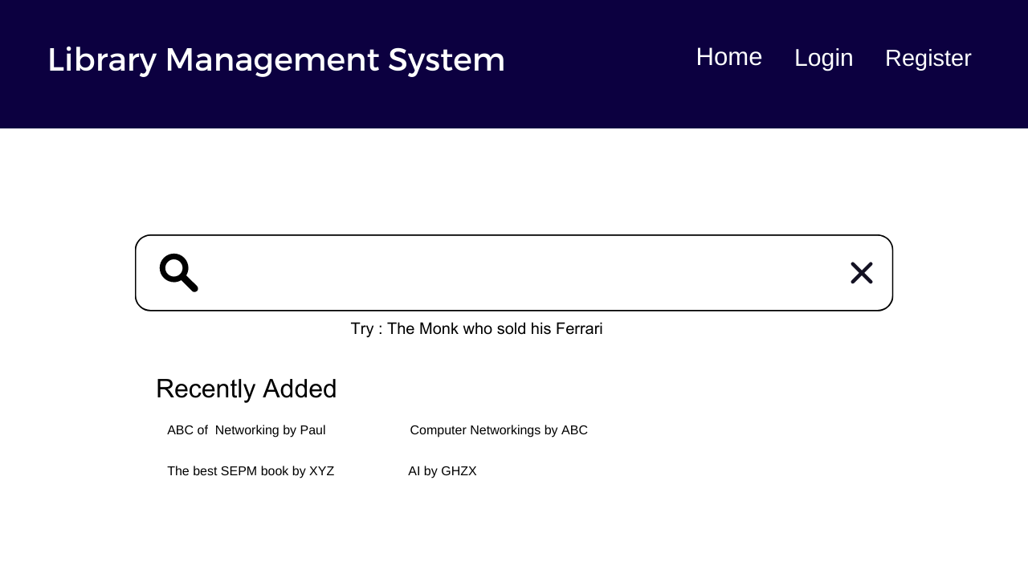

43

1. Managing Book List Design

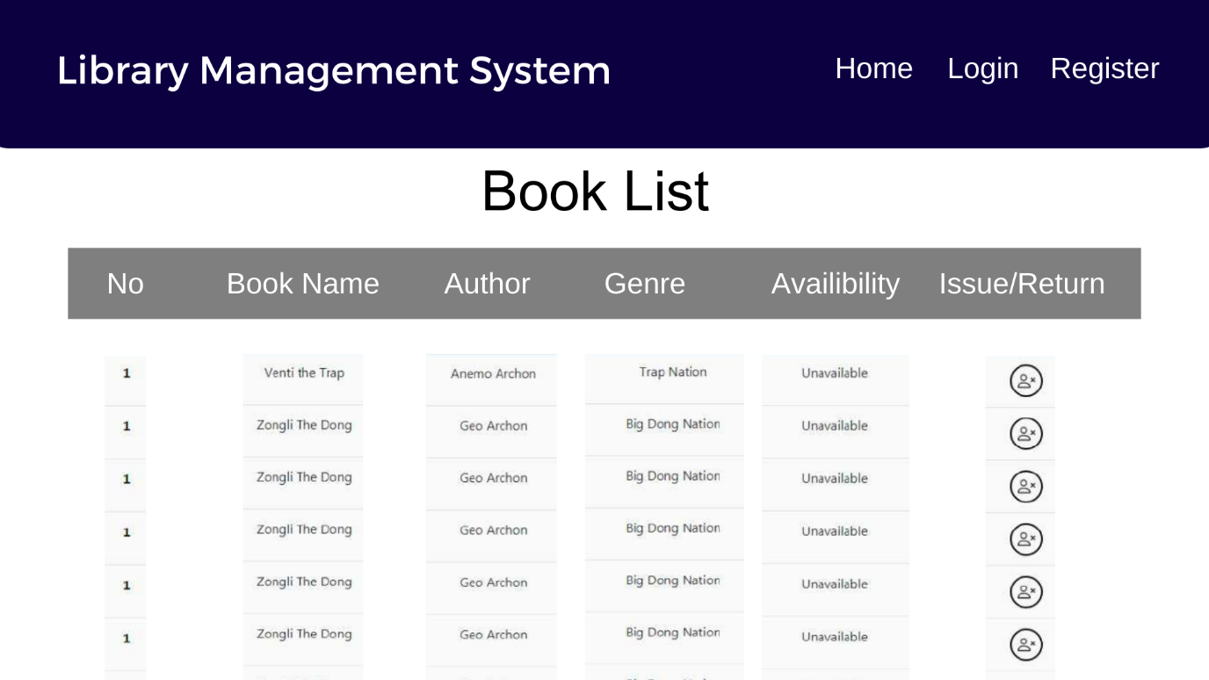

1. Issuing/Returning a Book Design

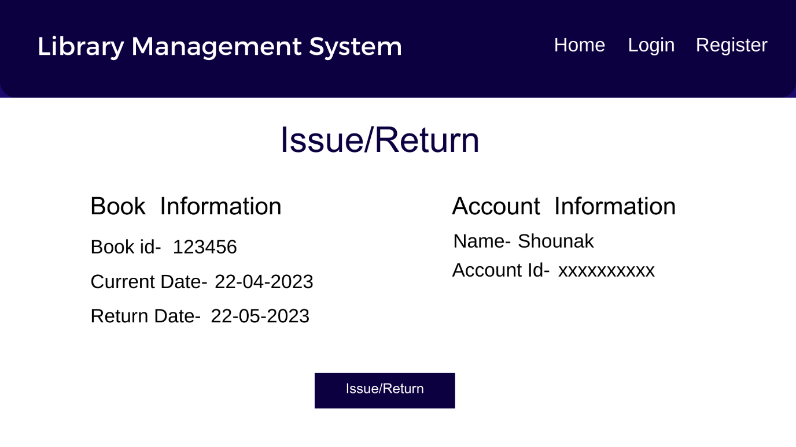

**Result:**

Thus, the details of architectural design/framework/implementation along with the screenshots were provided.

44

**CONCLUSION**

In conclusion, this report has presented the development of a Library Management System designed to address the challenges associated with managing book libraries in large organizations and companies. The proposed system offers a basic set of features that automate the processes involved in managing a library and enhance the user experience. The system's design ensures strong data security and good libraries, which reduces the risk of data inconsistency and integrity issues.

The proposed Library Management System provides an efficient and secure way to manage book libraries, enabling librarians to add/update members, add/update books, manage check-ins, and maintain records of issued books, late fines, and stock availability in the library. The system's design also allows librarians to retrieve details of books available in the library, issue books to students, and maintain their records.

Overall, the proposed Library Management System offers an opportunity for organizations to streamline their library management processes, reduce the risk of data inconsistency and integrity issues, and improve the user experience. The proposed system can be further customized and improved based on the client's specific requirements and can serve as a model for future library management systems.

**REFERENCES**

[1] R. Kumar, "Design and Development of Library Management System," International Journal of Advanced Research in Computer Science and Software Engineering, vol. 3, no. 3, pp. 199-204, Mar. 2013.

[2] S. Gupta, "Development of Library Management System," International Journal of Engineering Research and Applications, vol. 5, no. 2, pp. 6-9, Feb. 2015.

[3] A. Jain and P. Verma, "Design and Development of Library Management System," International Journal of Computer Science and Mobile Computing, vol. 4, no. 10, pp. 85-91, Oct. 2015.

[4] K. Ahmad, "Development of an Integrated Library Management System," International Journal of Scientific and Research Publications, vol. 4, no. 12, pp. 187-191, Dec. 2014.

[5] M. M. A. Hasan, A. K. Das, and M. R. Islam, "Design and Development of Library Management System," International Journal of Computer Applications, vol. 119, no. 2, pp. 13-17, Jun. 2015.